FPV antenna selection – A guide to help you select the best antenna system for you.

Antennas are the critical link between a transmitter and receiver, so it is best to select the proper antennas for your FPV scenario for the best possible flight experience. If you refer to the “How to be successful in FPV” guide, you will note that one of the big points is that there is no such thing as best. There is however, the one that works best for me. This guide will help you find that system.

Step 1 – Select polarization type

Polarization – Circular or linear?
Recently a few FPVer’s including myself have discovered the merits of circular polarization. Circular polarization is not for everyone, but does give the most consistent performance. Linear is more common, much simpler and is sometimes capable of longer range. So which do you choose and why?

Circular polarization:
Circular polarization is used by NASA and many HAMs to communicate with satellites that orbit the Earth as the orientation of the satellite is consistently changing. This is very similar to an FPV aircraft in flight. Circular polarization has two distinct advantages: it rejects multipath interference (which is the most common reason for video issues), and does not lose polarization when a plane banks to turn. If you are having trouble with video scrambling or random drop outs, this is likely due to multipath interference. MULTIPATHING IS NOT FUZZ IN THE VIDEO! MUTIPATHING IS SCRAMBLING OR SUDDEN DROP OUTS!

When to use circular polarization:
- When where your base station is near (within 100 feet) of large structures such as houses or buildings
- When standing on a porch or deck of a house or apartment or other building
- When stunt flying
- When flying behind trees and objects
- When doing low altitude flying
- When flying very high altitude (with a directional antenna)
Linear polarization:
Linear polarization is very common and is the easiest to implement. It is capable of longer range than circular polarization, but is more susceptible to multipathing. The range advantage is seldom realized due to multipath interference. The antennas tend to be more compact and easier to build (as well as cheaper to buy).

When to use linear polarization:
- When flying out in the open with no structures nearby
- When flying planes that do not bank sharply
- When going for long distance runs
- When standing on top of a hill or mountain
- Where antenna compactness is needed

What if my flight goals encompass several merits of each type of polarization? This is often the case with most FPVers. You can’t have it all so you must make an educated guess. If you are a current FPVer and are having problems with video drop outs and scrambling, then circular polarization will help you. If your problem is that you are getting fuzz in the video due to going very long range, use linear polarization.

Step 2 – Determining the best antenna pattern
First, I recommend watching this video: http://www.vimeo.com/8826952

RX antenna selection – How much gain do I want?
Now it’s time to determine how much directivity (gain) is best for you. This will be determined by your flight area and where you wish for your plane to go. As the gain of your antenna increases, so does the available range of the video system. Unfortunately, higher gain antennas have narrower beams and thus are not suitable for short range missions.
Omni directional antennas provide great coverage when flying near the base station, but do not do well for long range missions. Similarly, a high gain grid or dish antenna would make a poor choice for flying around a park. Most FPVer’s will find that a moderate gain (between 5 and 9 dbi) antenna suits most of their needs.

Use omni directional antennas when:
- You plan to fly all around yourself
- When flying short range (2km or less)
- When standing in the middle of the flight field
- When you want a quick and easy set up

Use moderate gain (5-9 dbi) antennas when:
- You plan to fly moderate range (2-8km)
- You want to fly an area out in front of you
- You desire more range than an omni, but want to be able to fly patterns and stunts
- When using an antenna tracker

Use high gain (10+ dbi) antennas when:
- Exploring an object or destination very far away
- When flying in a straight line and coming straight back
- When making long distance attempts
Examples of Omni antennas:
- ½ wave dipole (common rubber ducky type antenna)
- The Vee antenna
- Cloverleaf antenna
- Skew-planar wheel antenna
- The ground plane antenna
Examples of moderate gain antennas
- 3 or 4 element Yagi
- 8dbi patch
- 3 turn helical
- 8dbi circularly polarized patch
- 8dbi linearly polarized patch
- UniQuad antenna
Examples of High gain antennas
- Multi element Yagis
- Grid or dish antennas
- BiQuad or double BiQuad
- Patch antenna arrays
- 14 dbi patch antenna

TX antenna selection: What do I fly on the plane?
While there is much discussion on which antenna should be used on the ground, the aerial antenna is less discussed because there are fewer choices, but it is no less important. Generally speaking, lower gain antennas are better for airplanes, but helicopters and long distance runs might opt for higher gain omni antennas.

Since the choices are few, I will discuss each type:
The ½ wave dipole – This is the antenna to which all others are compared. With a moderate 2.15 dbi gain, the antenna has a large null over the top and bottom of the antenna. This is best used for long range attempts.
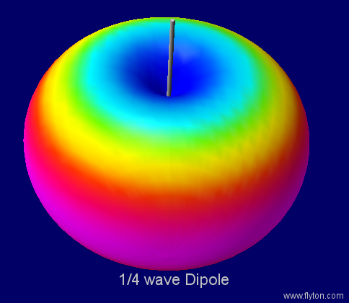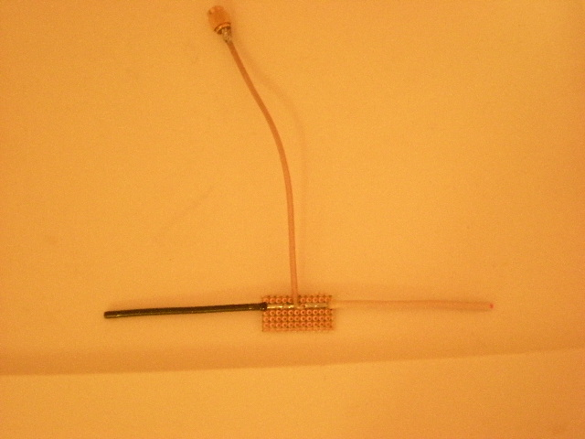

Inverted Vee antenna – Introduced in 2009 by Alex Greve (IBCrazy) as a better omnidirectional antenna for FPV flying. It has lower isotropic gain (~1.9dbi) than a dipole, but has no holes in the radiation pattern. This has been the antenna of choice for many FPV pilots and is perhaps the best linearly polarized general purpose antenna.
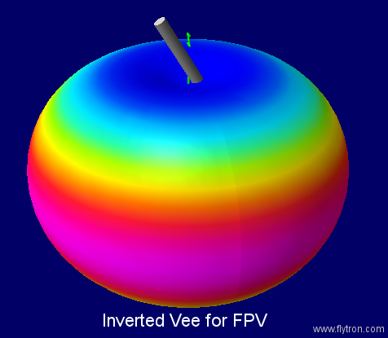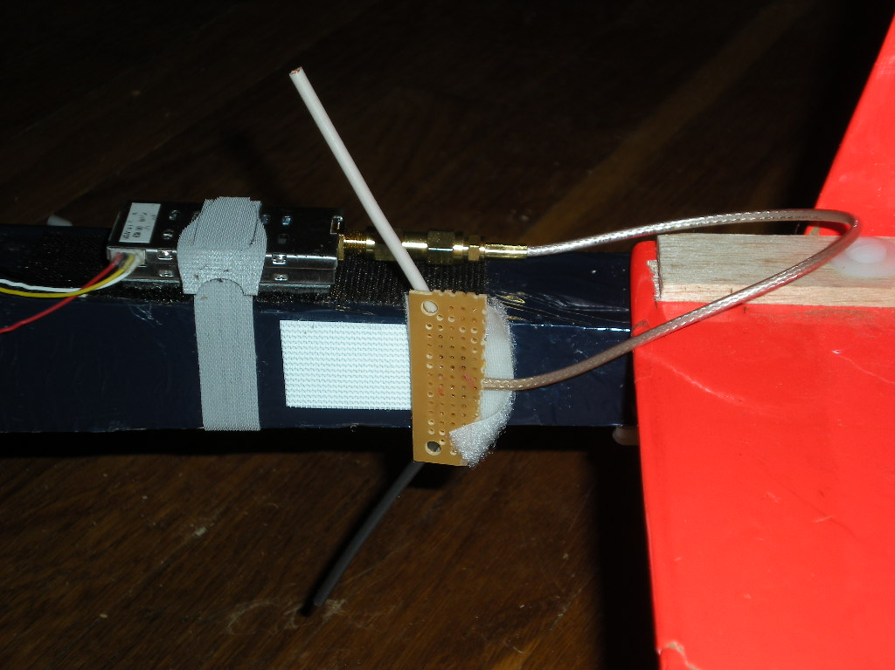

Skew-Planar Wheel – Relatively low gain (.92dbic) this antenna is circularly polarized and has excellent multipath rejection capability. This antenna is used for general purpose flying where aerodynamic drag is not a critical factor. This antenna was introduced in 2010 by Nigel (devonboy) which opened up the doors to CP on the airplane.
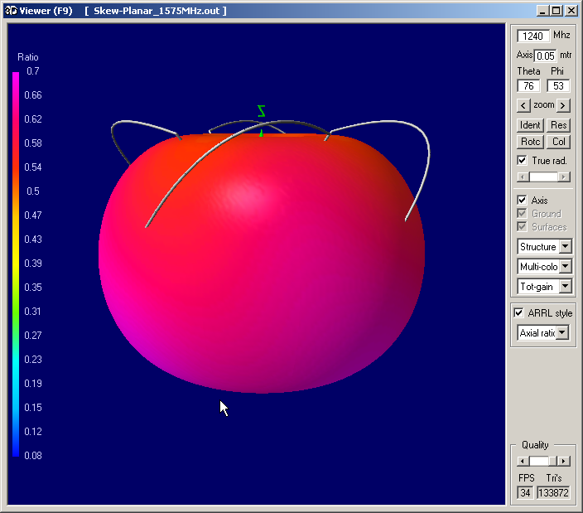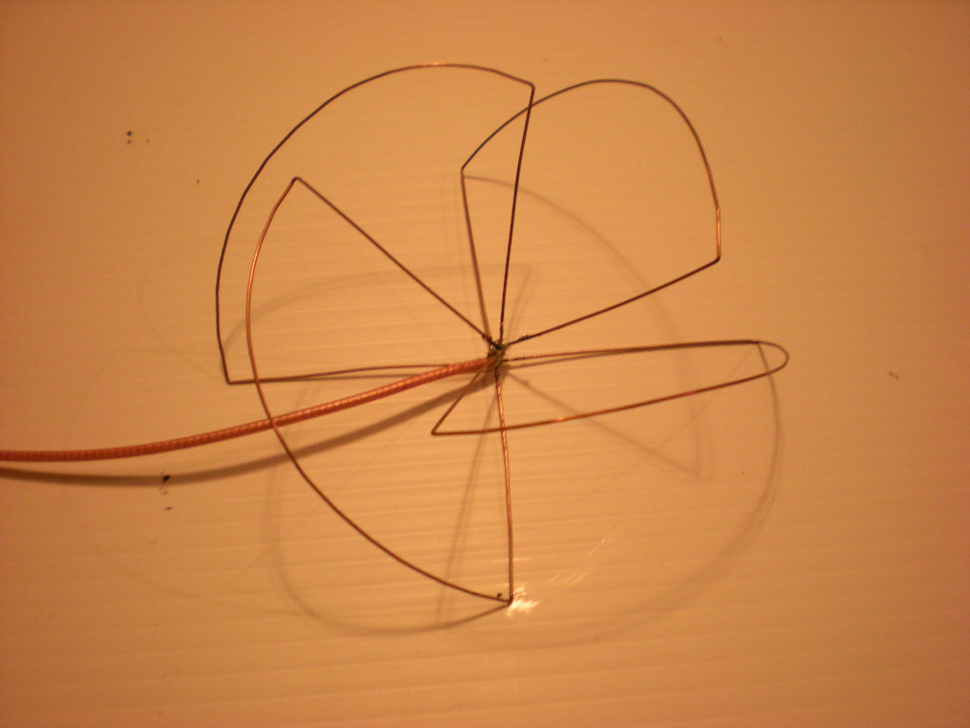

The Cloverleaf – With moderate gain (1.25 dbic) this antenna is slightly longer range than the Skew planar wheel antenna, but has a slightly oblong horizontal pattern. This antenna is great for general purpose flying and moderate range where less aerodynamic drag is required. This is the newest aerial antenna to the FPV world. Designed by Alex (IBCrazy) as an easier to build higher gain substitute for the Skew-planar wheel.
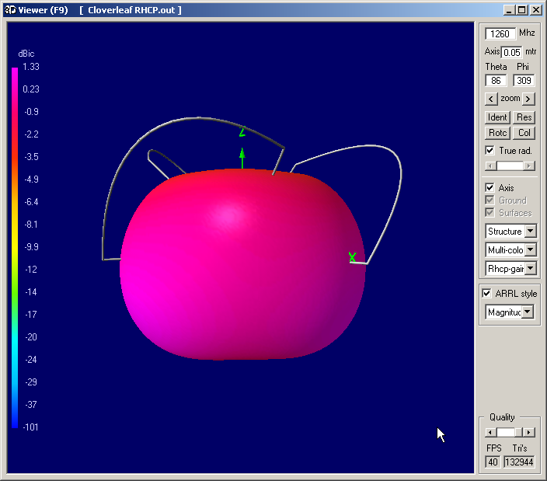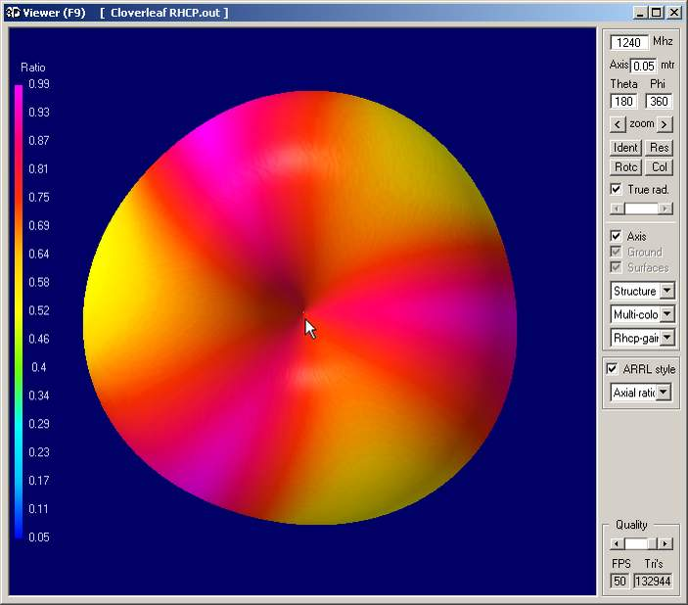
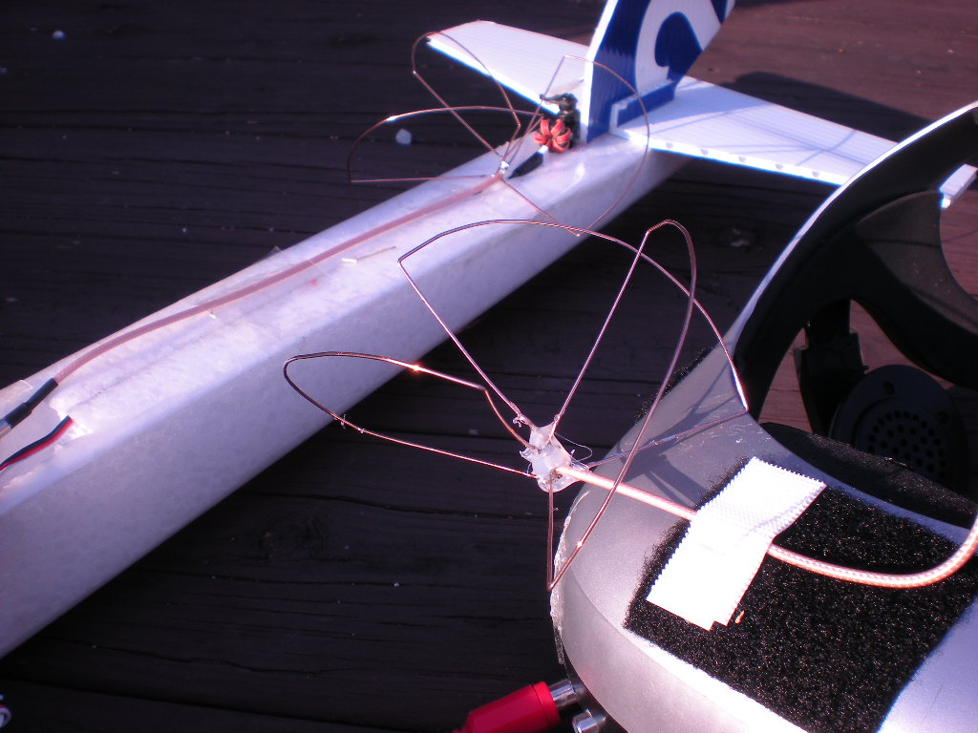

Choosing the proper RX antenna:
Here I will some of the common antennas we use for FPV and de-bunk some myths as well. The omni directional antennas listed above all work for RX applications as well and therefore will not be discussed here.

Linear patch antenna – This antenna is by far the most common directional FPV antenna. With compact size and a 70 degree beam width this allows a good sweep of coverage right out in front of you. This antenna is ground plane dependent, however, and performs best when mounted just a few inches off of the ground. Frequencies above 2GHz may find that this antenna can be mounted high in the air with minimal problems.
The low mounting requirement is the antenna’s greatest downfall. It makes flying in hilly areas difficult as the Fresnel zone is easily disrupted.
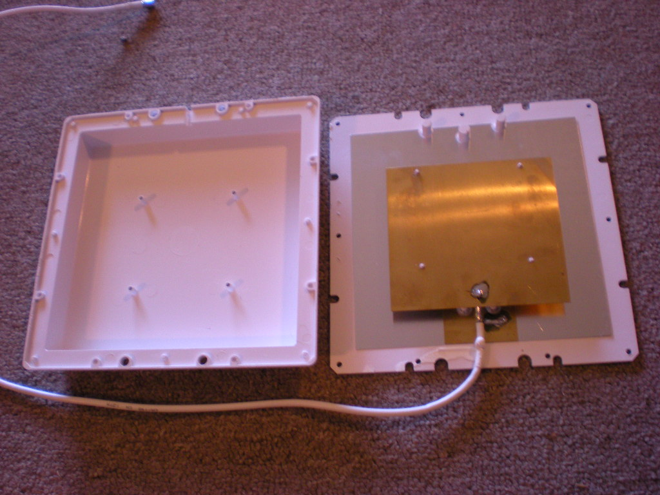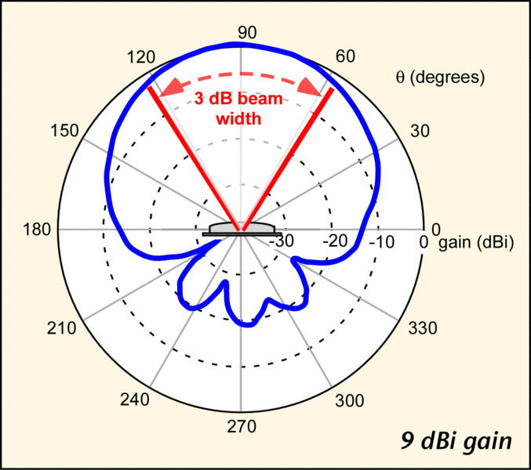
Yagi antenna – A much less commonly flown antenna than the patch, this antenna is found in a wide range of gain values. The beam on this antenna is fairly narrow but it is easy to aim and can be mounted up on a tripod or stand as it is not ground plane dependent. It is a good choice for an antenna tracker provided the tracker is strong enough to take the weight of the antenna.
The greatest downfall with the Yagi is moisture. Moisture causes degradation of antenna performance as more elements are added.
UniQuad antenna – The BiQuads 8 dbi little brother. The uniQuad is a wide bad highly efficient antenna. It is very similar to the patch antenna except that it is more efficient and not ground plane dependent.
This antenna is currently under development by Alex Greve (IBCrazy). There is no real downfall to this antenna.
BiQuad antenna – The BiQuad is a very efficient 11dbi antenna. Perhaps even less common than the Yagi, this antenna shares the compact size of the patch without the dependence on a ground plane. The antenna has small side lobes which help in landing. This antenna works well with antenna trackers.
The greatest downfalls of this antenna are that it is hard to find (it must be built as it isn’t commercially available) and it is fragile.
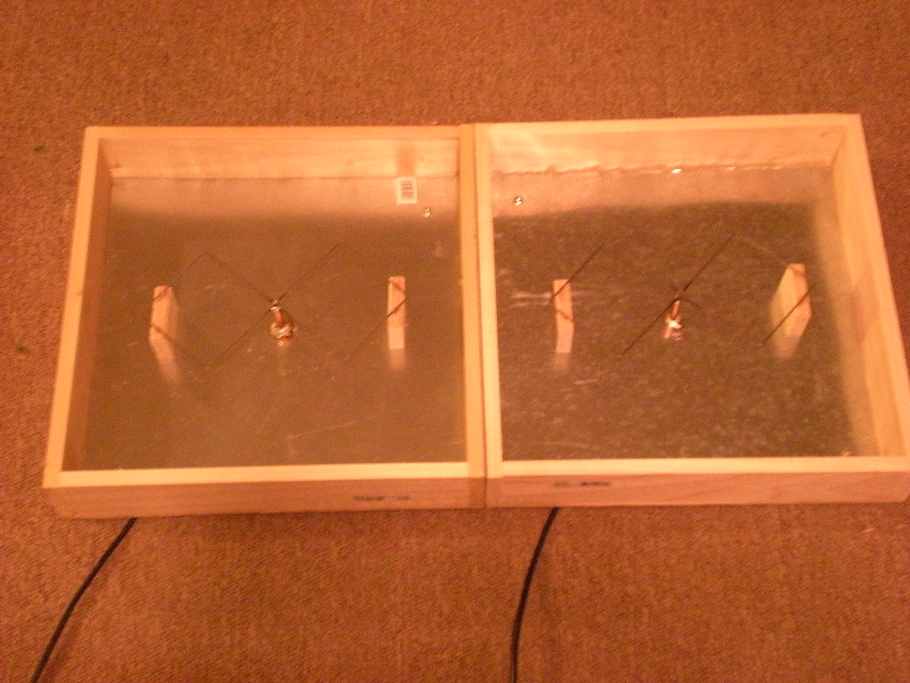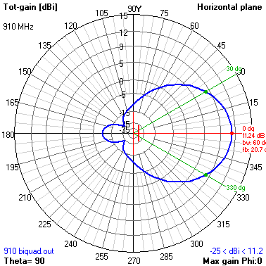

Grid antenna – Commonly used for long range, this antenna is highly directive. Gains can range from 15-24dbi. This antenna is not ground plane dependent and is best mounted high in the air.
The greatest downfall of a grid antenna is efficiency. Grids are seldom more than 60% efficient. So while your range capability is great, you must fly in a very narrow beam.

Helical antenna – This antenna is circularly polarized with exceptional axial ratio and multipath rejection. It is extremely broadband and can be made for a wide range of gains. Smaller units can be mounted to an antenna tracker.
The greatest problems with the helical is that the efficiency is often not exceptional (between 60 and 80%) and that they are not readily available commercially.

CP Patch – Similar to the linear patch, but circularly polarized. This antenna is compact and easy to use.
The problems with this antenna are its low axial ratio (multipath rejection capability), and that it is ground plane dependant.

CP BiQuad – The CP BiQuad is an 8dbi circularly polarized antenna. It has a compact size that is suitable for antenna trackers and is not ground plane dependent. Alex (IBCrazy) is currently developing this antenna.
The greatest downfall of this antenna is that it has not been perfected yet and therefore will not be available for some time.

More information:
More information can be found by watching Andology’s video: http://www.vimeo.com/8826952

Or by visiting IBCrazy’s blog: http://www.rcgroups.com/forums/member.php?u=103113

